Right Rhombohedron

Definition
# Source: AI Source: Provided by: [Data Path: Persons Table -> ID Column: 1, Name_En Column: Motasem Essam] -> From: [ChatGPT] on [7/25/2026]
A Right Rhombohedron is a rhombohedron in which the three principal edge directions meeting at a vertex are mutually perpendicular.
However, because a rhombohedron has 12 equal edges, three mutually perpendicular edge directions produce a cube.
Therefore, a right rhombohedron is geometrically a special case of a cube rather than a distinct non-cubic rhombohedron.

Simple Definition
# Source: AI Source: Provided by: [Data Path: Persons Table -> ID Column: 1, Name_En Column: Motasem Essam] -> From: [ChatGPT] on [7/25/2026]
A right rhombohedron is a solid with six congruent rhombus faces whose three edge directions meet at right angles.
Since those angles are all ${90}^{∘}$, each rhombus face becomes a square. The resulting solid is a cube.

Geometric Structure
# Source: AI Source: Provided by: [Data Path: Persons Table -> ID Column: 1, Name_En Column: Motasem Essam] -> From: [ChatGPT] on [7/25/2026]
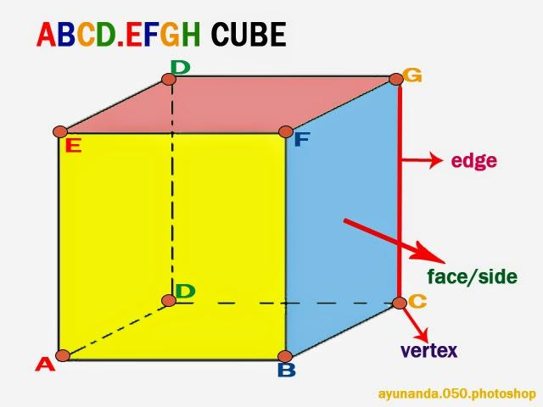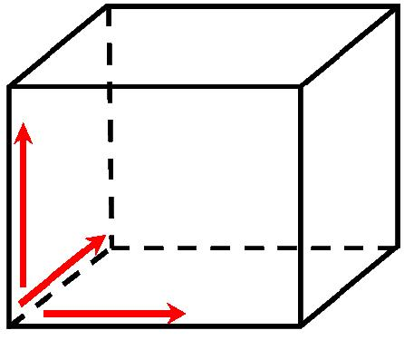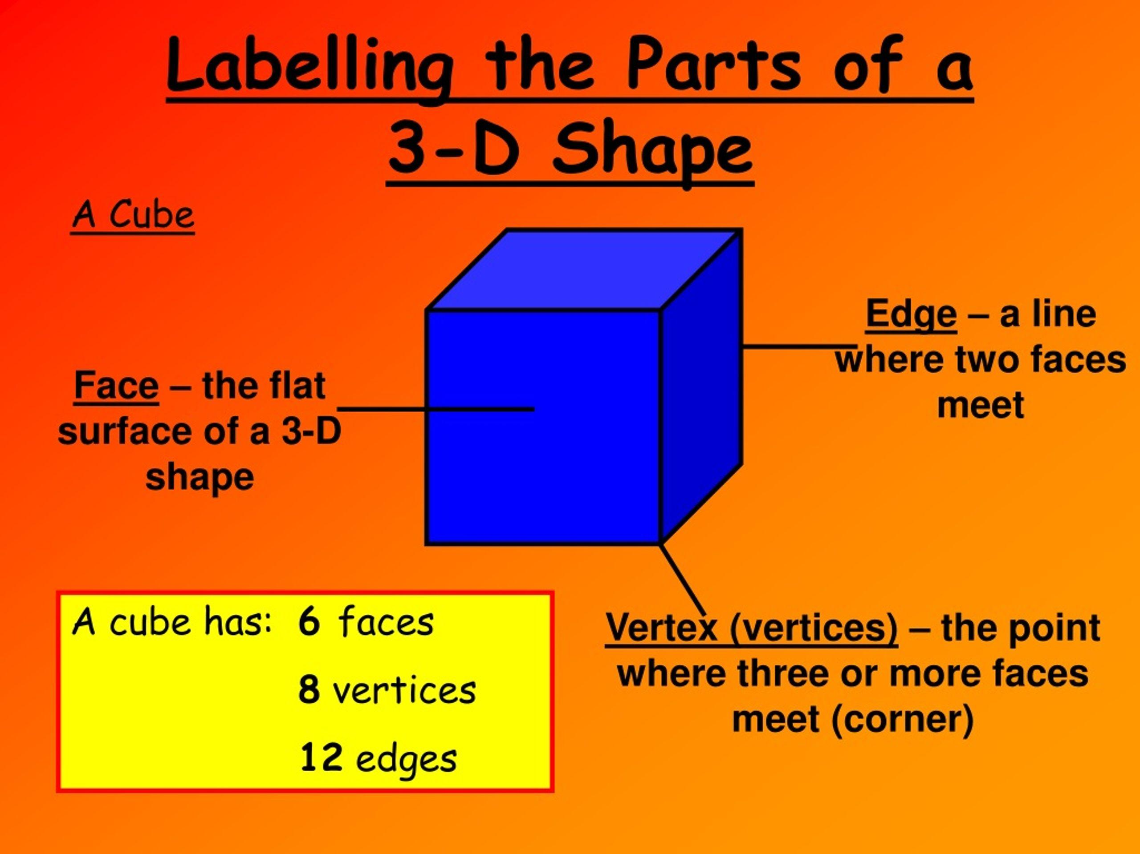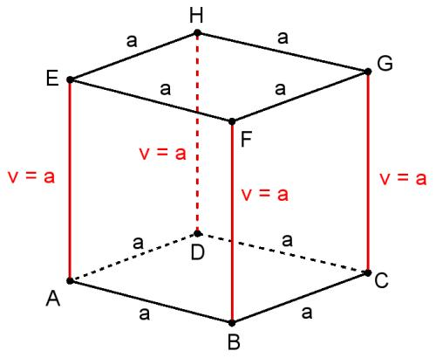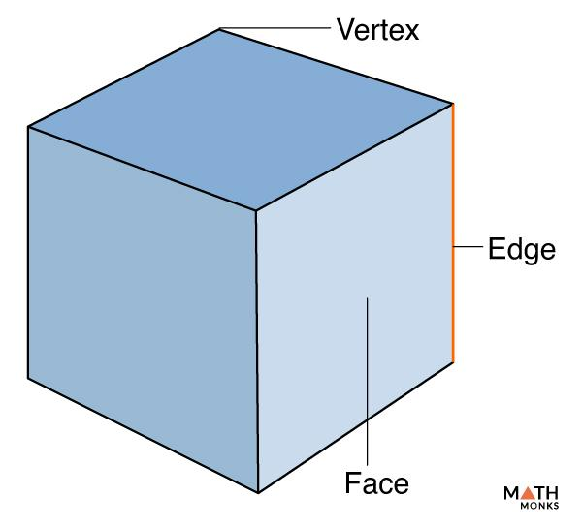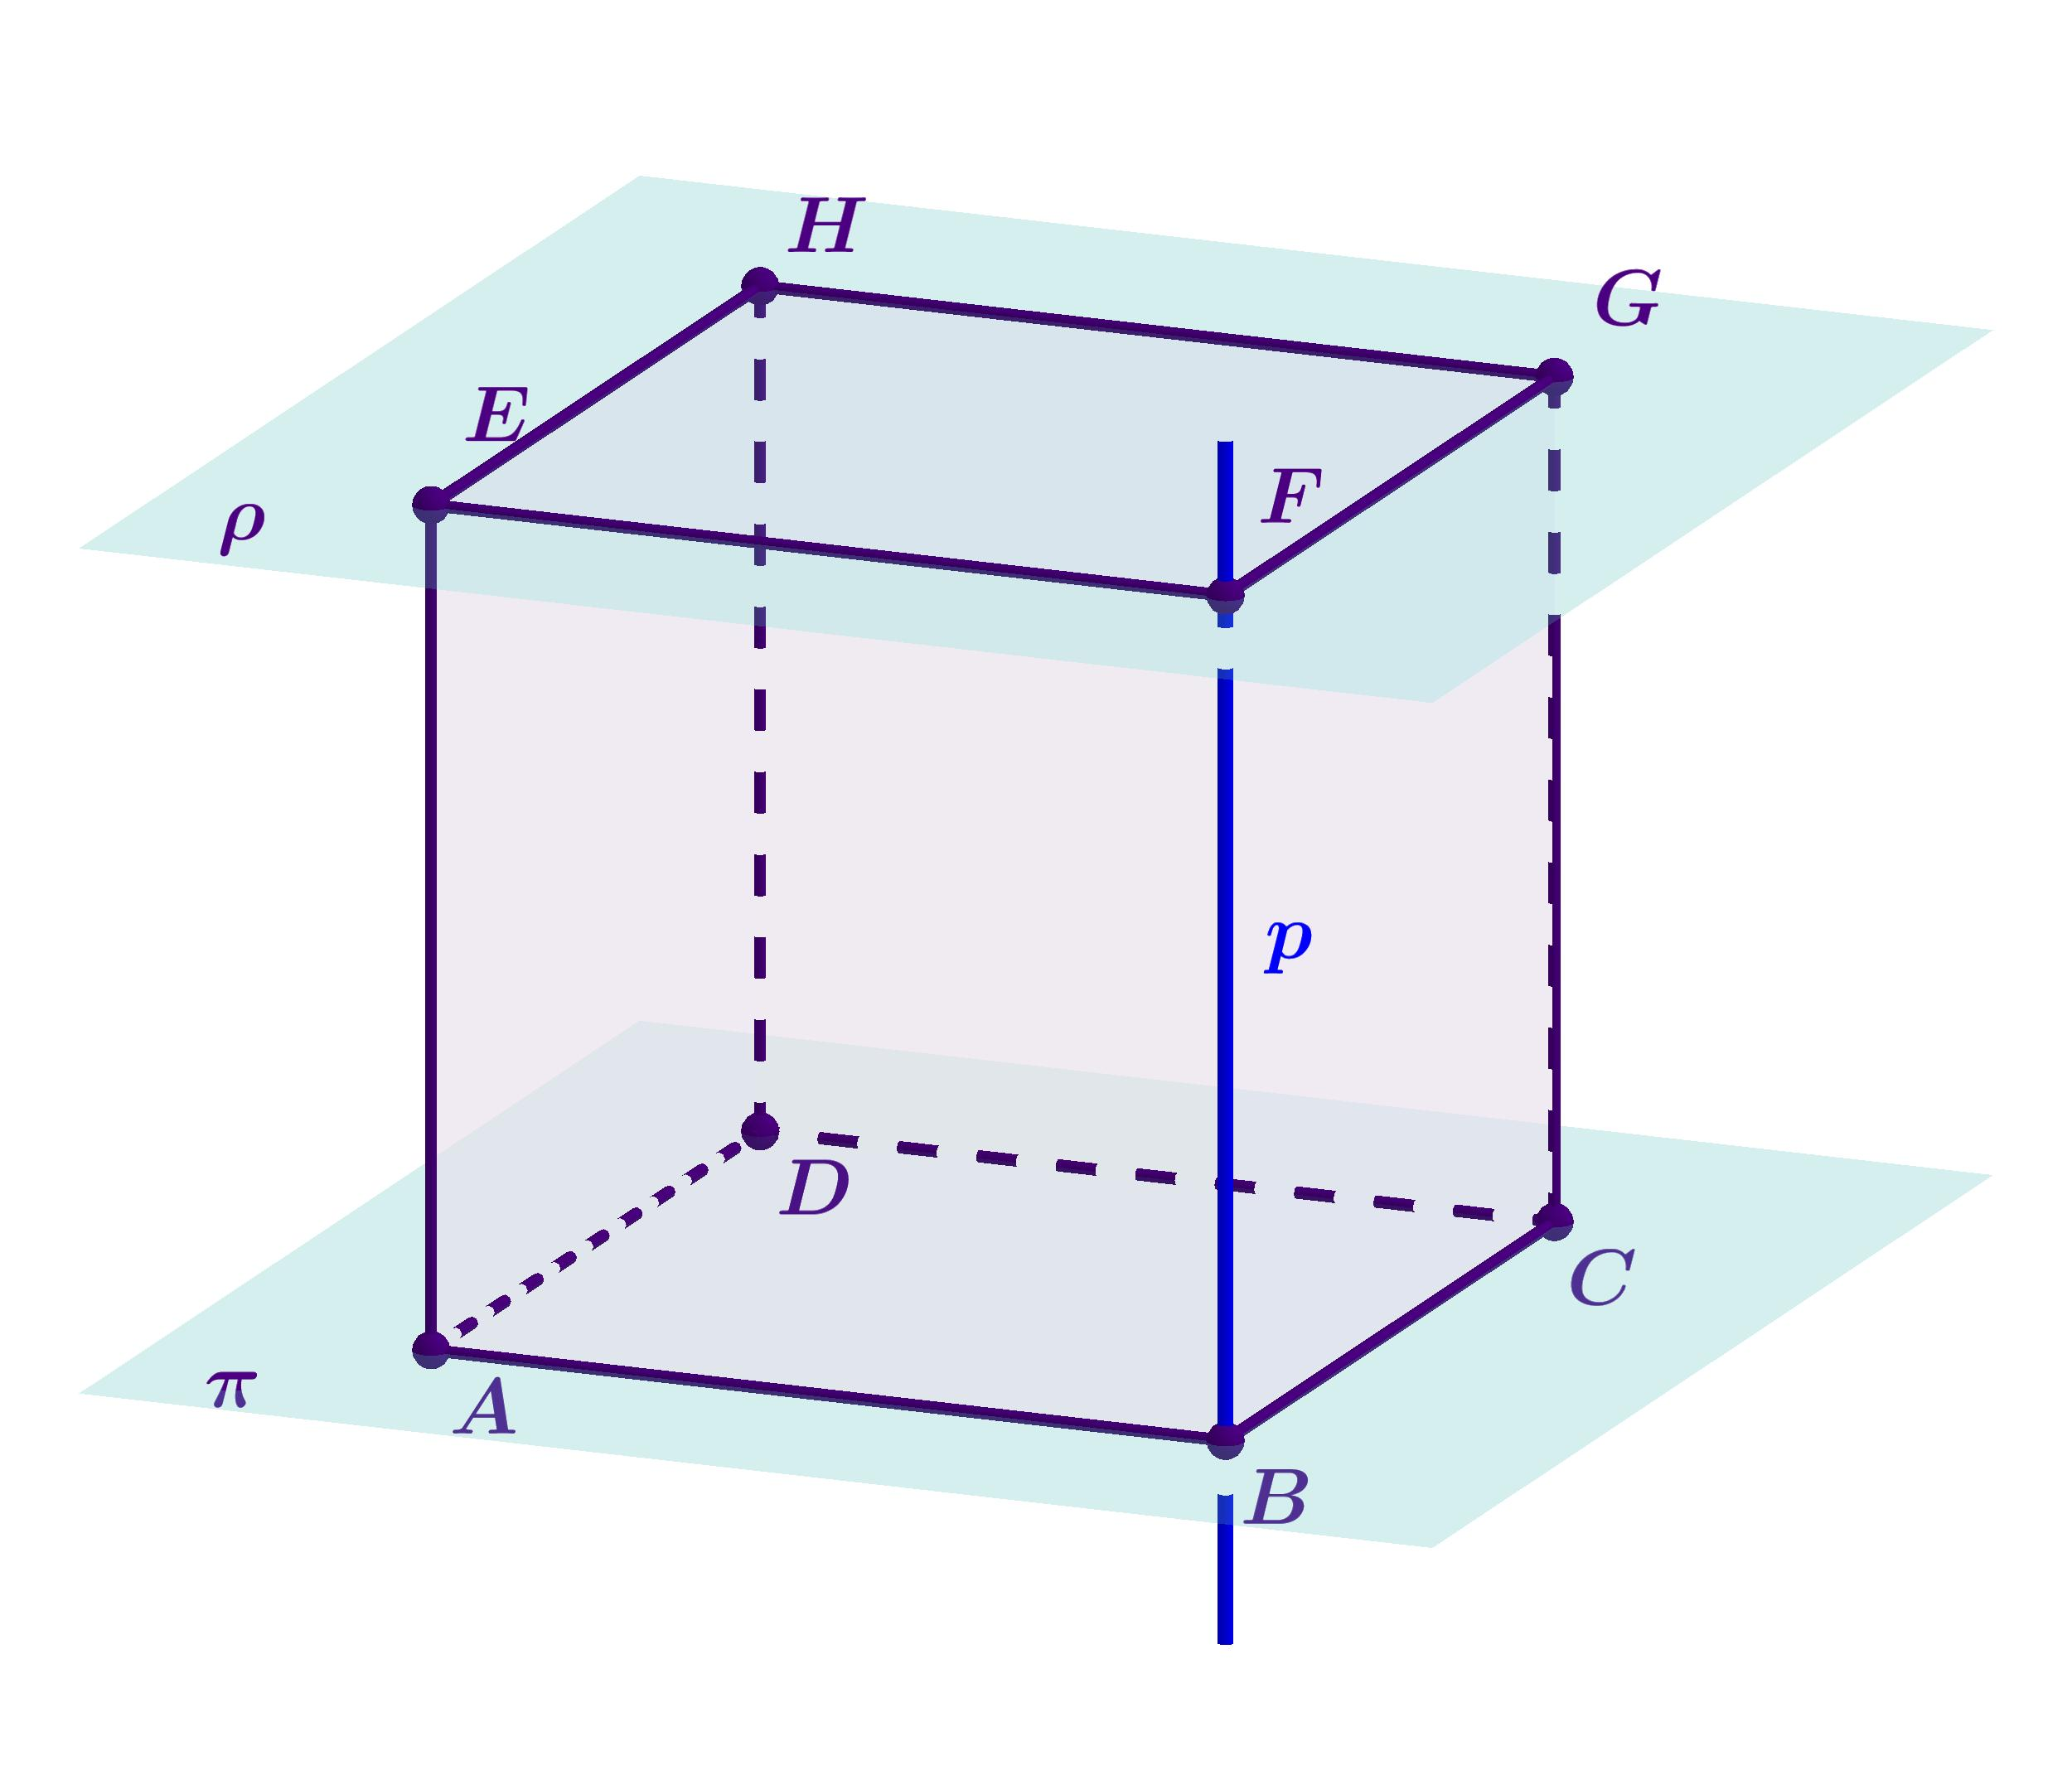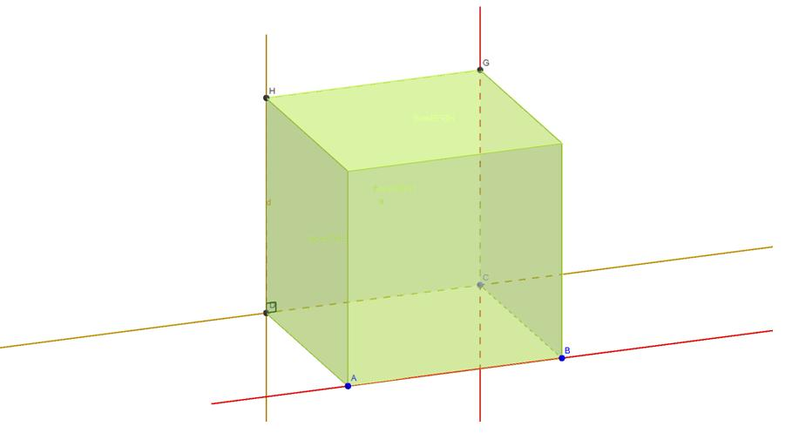
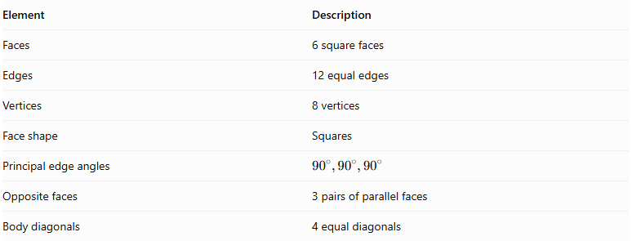
Element | Description
Faces | 6 square faces
Edges | 12 equal edges
Vertices | 8 vertices
Face shape | Squares
Principal edge angles | $${90}^{∘},{90}^{∘},{90}^{∘}$$
Opposite faces | 3 pairs of parallel faces
Body diagonals | 4 equal diagonals

Mathematical Properties
# Source: AI Source: Provided by: [Data Path: Persons Table -> ID Column: 1, Name_En Column: Motasem Essam] -> From: [ChatGPT] on [7/25/2026]
Let $s$ represent the common edge length.

A. Face Area
# Source: AI Source: Provided by: [Data Path: Persons Table -> ID Column: 1, Name_En Column: Motasem Essam] -> From: [ChatGPT] on [7/25/2026]
Each face is a square:
$$A_{face}=s^{2}$$

B. Surface Area
# Source: AI Source: Provided by: [Data Path: Persons Table -> ID Column: 1, Name_En Column: Motasem Essam] -> From: [ChatGPT] on [7/25/2026]
$$SA=6s^{2}$$

C. Volume
# Source: AI Source: Provided by: [Data Path: Persons Table -> ID Column: 1, Name_En Column: Motasem Essam] -> From: [ChatGPT] on [7/25/2026]
$$V=s^{3}$$

D. Face Diagonal
# Source: AI Source: Provided by: [Data Path: Persons Table -> ID Column: 1, Name_En Column: Motasem Essam] -> From: [ChatGPT] on [7/25/2026]
$$d_{f}=s\sqrt{2}$$

E. Body Diagonal
# Source: AI Source: Provided by: [Data Path: Persons Table -> ID Column: 1, Name_En Column: Motasem Essam] -> From: [ChatGPT] on [7/25/2026]
$$d_{b}=s\sqrt{3}$$

Symmetry
# Source: AI Source: Provided by: [Data Path: Persons Table -> ID Column: 1, Name_En Column: Motasem Essam] -> From: [ChatGPT] on [7/25/2026]
A right rhombohedron has the same symmetry properties as a cube:
- 9 planes of reflectional symmetry.
- 3 fourfold rotational axes through the centers of opposite faces.
- 4 threefold rotational axes through opposite vertices.
- 6 twofold rotational axes through the midpoints of opposite edges.
- A center of inversion symmetry.

Worked Examples
# Source: AI Source: Provided by: [Data Path: Persons Table -> ID Column: 1, Name_En Column: Motasem Essam] -> From: [ChatGPT] on [7/25/2026]
Example 1: Calculate the volume
Given:
$$s=5 cm$$
$$V=s^{3}=5^{3}$$
$$\boxed{V=125{ cm}^{3}}$$
Example 2: Calculate the total surface area
Given:
$$s=4 cm$$
$$SA=6s^{2}=6(4^{2})$$
$$\boxed{SA=96{ cm}^{2}}$$

Constructing Right Rhombohedron in Solid Geometry

Geometric Instruments Used
# Source: AI Source: Provided by: [Data Path: Persons Table -> ID Column: 1, Name_En Column: Motasem Essam] -> From: [ChatGPT] on [7/25/2026]
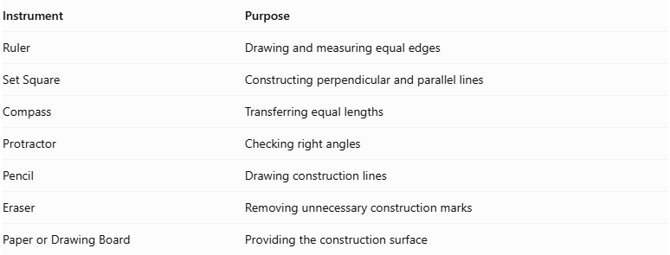
Instrument | Purpose
Ruler | Drawing and measuring equal edges
Set Square | Constructing perpendicular and parallel lines
Compass | Transferring equal lengths
Protractor | Checking right angles
Pencil | Drawing construction lines
Eraser | Removing unnecessary construction marks
Paper or Drawing Board | Providing the construction surface

Instrument-Based Construction Procedures

Isometric Construction
# Source: AI Source: Provided by: [Data Path: Persons Table -> ID Column: 1, Name_En Column: Motasem Essam] -> From: [ChatGPT] on [7/25/2026]
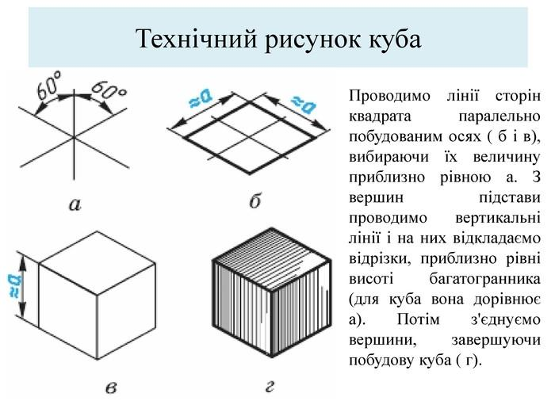
- Select the required edge length.
- Draw a front edge representing one side of the cube.
- From its endpoints, draw two equal receding edges using the isometric drawing directions.
- Complete the parallelogram representing the visible base.
- Draw equal vertical edges from the base vertices.
- Connect their upper endpoints to form the top face.
- Complete the remaining edges.
- Verify that all twelve edges represent equal lengths.

Orthographic Construction
# Source: AI Source: Provided by: [Data Path: Persons Table -> ID Column: 1, Name_En Column: Motasem Essam] -> From: [ChatGPT] on [7/25/2026]
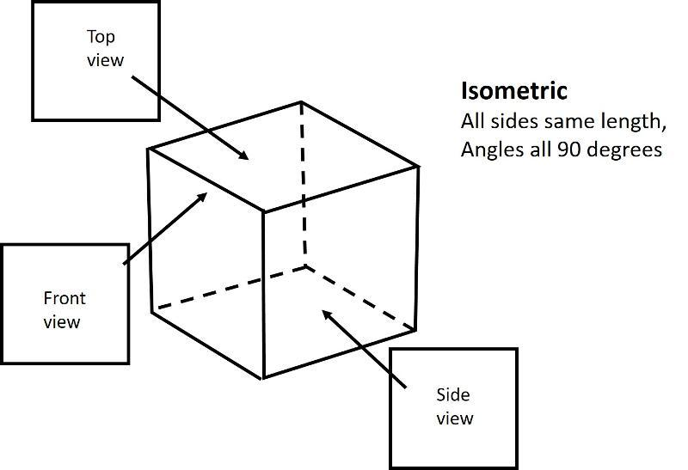
- Draw a square representing the front view.
- Draw an equal square for the top view.
- Draw an equal square for the side view.
- Align the corresponding edges of the three views.
- Verify that all three dimensions are equal.
- Add dimension lines and labels.

Face-Based Construction
# Source: AI Source: Provided by: [Data Path: Persons Table -> ID Column: 1, Name_En Column: Motasem Essam] -> From: [ChatGPT] on [7/25/2026]
- Construct one square face using a ruler and set square.
- Construct five additional congruent squares.
- Arrange the six squares in a suitable connected net or assembly arrangement.
- Match the corresponding edges.
- Fold or assemble the faces to form the cube.
- Verify that all six faces are squares.

Edge-Based Construction
# Source: AI Source: Provided by: [Data Path: Persons Table -> ID Column: 1, Name_En Column: Motasem Essam] -> From: [ChatGPT] on [7/25/2026]
- Select the common edge length.
- Draw three mutually perpendicular principal edge directions.
- Construct equal edges along these three directions.
- Complete the twelve edges using parallel-line construction.
- Connect the vertices to form six square faces.
- Check perpendicularity and edge equality.

Net-Based Construction
# Source: AI Source: Provided by: [Data Path: Persons Table -> ID Column: 1, Name_En Column: Motasem Essam] -> From: [ChatGPT] on [7/25/2026]
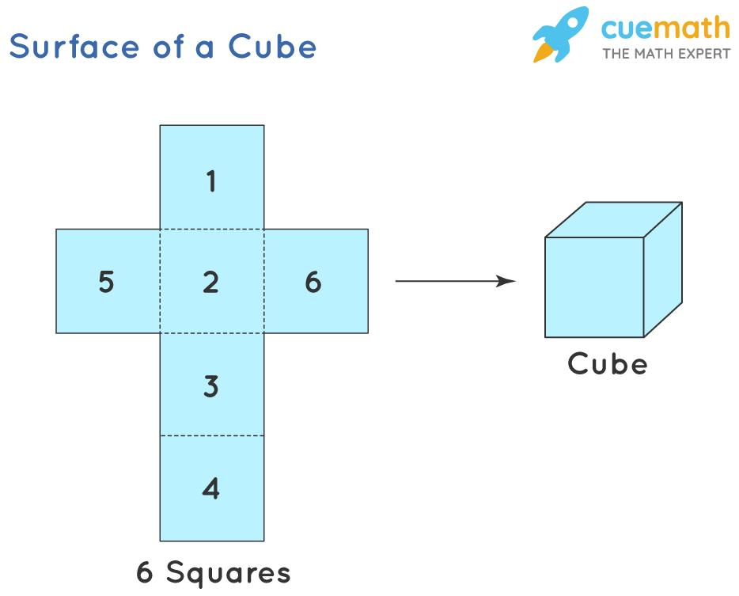
- Draw six congruent squares in a connected net arrangement.
- Ensure that each square has the same side length.
- Arrange the squares so that they can fold into a closed solid.
- Add tabs if the net is intended for physical assembly.
- Cut and fold the net along the shared edges.
- Join the faces to form the cube.

Relationship to Other Solids
# Source: AI Source: Provided by: [Data Path: Persons Table -> ID Column: 1, Name_En Column: Motasem Essam] -> From: [ChatGPT] on [7/25/2026]
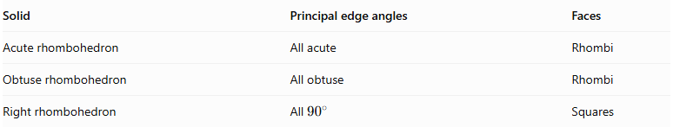
Solid | Principal edge angles | Faces
Acute rhombohedron | All acute | Rhombi
Obtuse rhombohedron | All obtuse | Rhombi
Right rhombohedron | All ${90}^{∘}$ | Squares

Key Points
# Source: AI Source: Provided by: [Data Path: Persons Table -> ID Column: 1, Name_En Column: Motasem Essam] -> From: [ChatGPT] on [7/25/2026]
- A rhombohedron has six congruent rhombus faces and twelve equal edges.
- A right rhombohedron has three mutually perpendicular principal edge directions.
- Its six rhombus faces become squares.
- It is therefore geometrically equivalent to a cube.
- Its volume is $s^{3}$, and its surface area is $6s^{2}$.

Conclusion
# Source: AI Source: Provided by: [Data Path: Persons Table -> ID Column: 1, Name_En Column: Motasem Essam] -> From: [ChatGPT] on [7/25/2026]
The Right Rhombohedron is the special perpendicular case of a rhombohedron. Because all its edges have equal lengths and its three principal edge directions meet at ${90}^{∘}$, all six faces are squares. Consequently, it is exactly a Cube.
Classification note: In a mathematical knowledge taxonomy, it is more precise to classify the cube as a special case of the rhombohedron rather than treat the right rhombohedron as a separate non-cubic solid.

